# Name: Abdurrahman Qureshi

# Roll no: 210451

## Practical no 16: -

Aim: Write PL/SQL Code to Create Triggers

* Practical Related Questions

1. Inserting Trigger

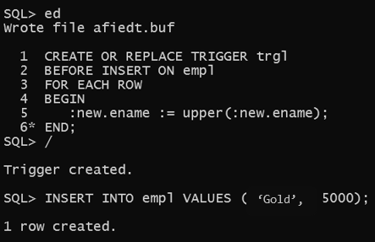

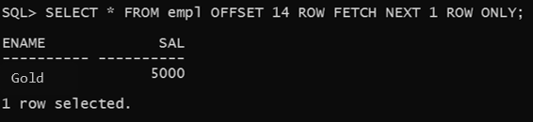

1. Restriction to Deleting Trigger

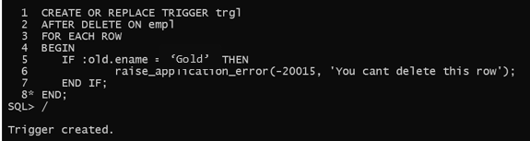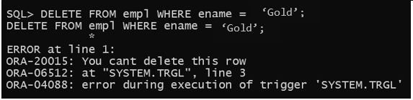

* Exercise

1. Create a row-level trigger for the EMP table that would fire for INSERT or UPDATE or DELETE operations performed on the EMP table. This trigger will display the salary difference between the old values and new values.

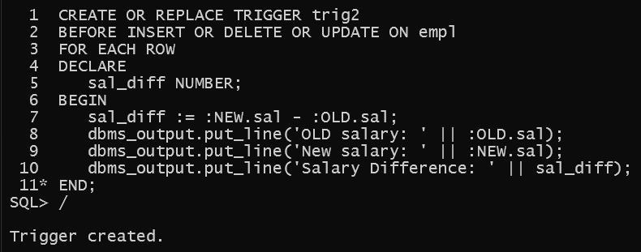

1. Insertion

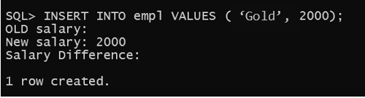

1. Update

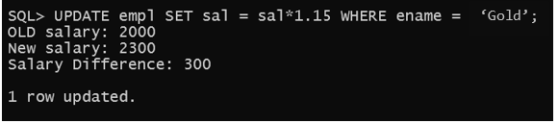

4.Deletion

